**Control Bot - Installation & Working Procedure**

INDEX

# 

**Installation 3**

Content 3

**Working Procedure 4**

Lock PC 4

Shutdown PC 5

Restart PC 6

Ping PC 6

Send Message 7

## 

## **INSTALLATION**

## Step 1: Enable IIS in the machine.

## Step 2: In IIS create a new website with a ControlBot name.

## Step 3: Explore the ControlBot file location then paste the build file.

## Step 4: Run the ControlBot in the browser.

## Step 5: Install remote client X app on system and make sure its running on background.

## 

## 

## **WORKING PROCEDURE**

## Working procedure of different control bot actions like lock PC, shutdown PC, restart PC, ping PC explained as follows.

First of all, we have to login to the CMS outlet using ADMIN-PC(server) and go to the control bot menu. Make sure PC’s listed on “Select PC” options are connected to the same LAN connection.

## **1. LOCK PC**

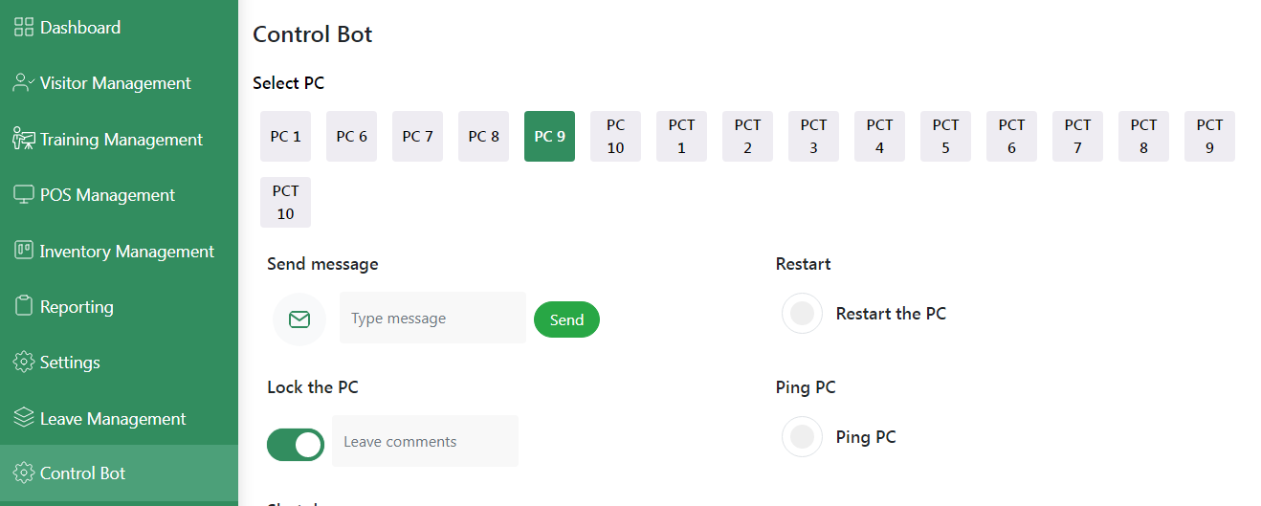

Select a PC which you want to LOCK by using control bot, then click on the “Lock the PC” toggle and enter the reason in the “Leave comments” field. But it’s an optional field.

Finally, check if the selected PC was locked or not.

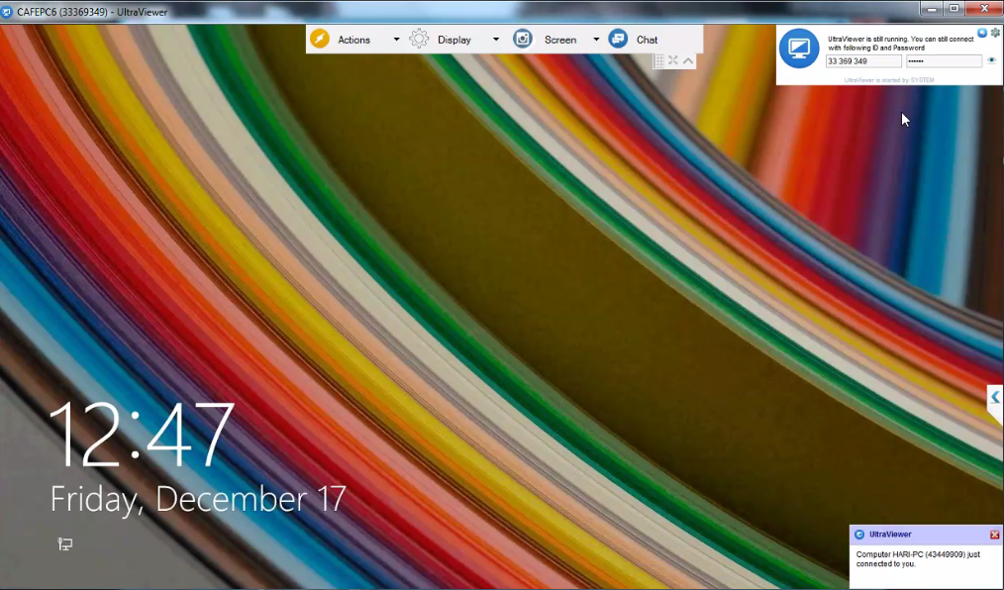

You are able to see the lock screen of the PC after successful attempt of LOCK PC action in the control bot.

## **2. SHUTDOWN PC**

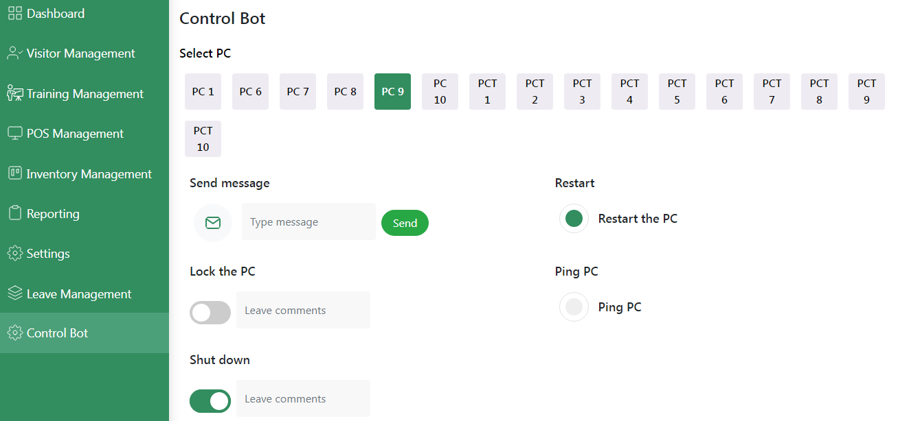

Select a PC which you want to SHUTDOWN by using control bot, then click on the “Shut Down” toggle and enter the reason in the “Leave comments” field. But it’s an optional field.

Finally, check if the selected PC was shut down or not. You are able to see the PC was shutdown after a successful attempt of SHUTDOWN PC action in the control bot.

## **3. RESTART PC**

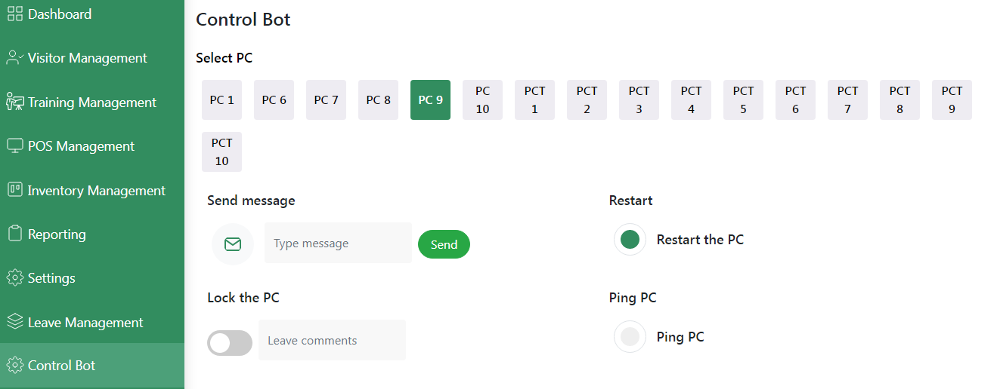

Select a PC which you want to RESTART by using control bot, then click on the “Restart the PC” radio button and check if the selected PC was restarted or not. You are able to see the PC was restart after a successful attempt of RESTART PC action in the control bot.

## **4. PING PC**

Select a PC which you want to PING by using control bot, then click on the “Ping PC” radio button and check if the selected PC was pinged or not. You are able to see the PC was pinged after a successful attempt of PING PC action in the control bot.

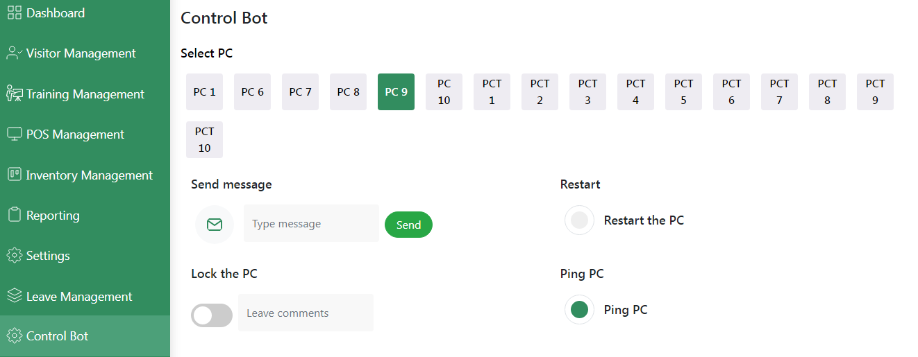

## **5. SEND MESSAGE**

We can send message by Entering message in the input box and then click send user can able to see message on their PC while remoteclientX app running on background.

